|  |
| --- |
| **Make PDF reader demo version** |

Hiren P has made a PDF reader for CreditDevice, and we should build further on that solution and make it into a commercial product. I think the user should be able to:  
(1) Specify a source  
(2) Define individual “Search words” in a table  
(3) Choose output (=database/Excel columns)

For a start we should make a “demo version” based on Danish annual reports PDF. I have attached 4 PDF examples, and I would like us to be able to extract:  
* Financial figures  
* Parent companies  
* Subsidiaries  
* Bankers

I believe the task is big, and it can go on for several months. At the moment we don´t have any clients for the product, but I believe it has potential. We should only work on the product when we have:  
* No other paid software development projects in scope  
* No program errors that need fixing

Finally I would like to stress that program should be user friendly = nice looking and easy to operate

**Suitable search search words to extract parent**

For a start please provide me with a list of the search words that are use in Netherland to identify financial figures. I will provide Danish translations of the Dutch words, and afterwards let´s see how the program works on the 4 Danish examples (= is it also possible to extract financial figures on Danish companies).

**Suitable search search words to extract parent companies and subsidiaries**

* In CVR-no.= 26093201 (=Balyfa) I would like us to extract “MG MarketSoft India Private limited, Indien” as subsidiary. Suitable search word here could be *“Dattervirksomhed”*

* In CVR-no. = 43137611(=Soft Inform) I would like us to extract "Balyfa Hungary Kft, Ungarn" as subsidiary. Suitable search word here could be *"Share of ownerships"*

* In CVR-no. = 15401281 (=Verifon) I would like us to extract the subsidiary "Verifone Services UK & Ireland Ltd." as subsidiary. Suitable search word here could be *“Associerede virksomheder”* or *”Associates”*. We should also be able to extract the owner percentage from the column in same line “50%” and the suitable search word is *“Ejerandel %”*

We should also extra the parent company “Verifone Norway AS” and “Verifone Systems Inc.” . Suitable search words here is *“Modervirksomhed”* or *“Parent company”* In this case it´s also possible to extract the country “Norway” and “USA” by using search words *“Bopæl”, “Hjemsted”* or *“Domicile”*

* In CVR-no. = 54562519 (Lego A/S) I would like us to extract “KIRKBI A/S” as parent company. Suitable search word here could be *“*ultimate Parent Company*”*

I would also like us to be able to extract all the subsidiaries below ...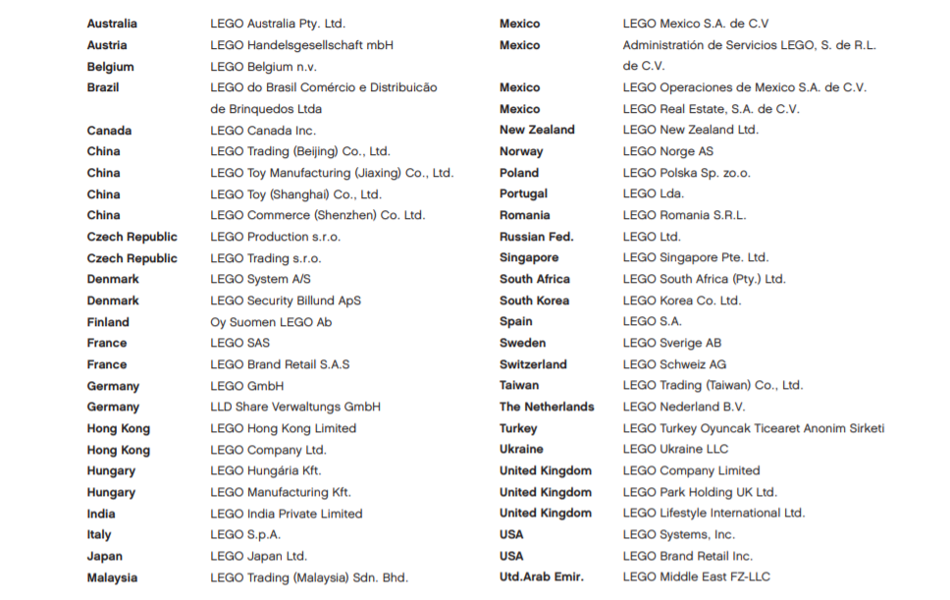

… because of the related text on the same page *“group subsidiaries”* (this might be tricky, but it would be great if we can solve it)

**Suitable search words for extracting bankers**

It´s only a few companies that show information about bankers in the annual report PDF. But please look for these search words “Bankforbindelse” or “Bankers”

On CVR-no = 15401281 (=Verifon) you wil find the 2 banks ”Danske Bank” and ”J.P. Morgan”